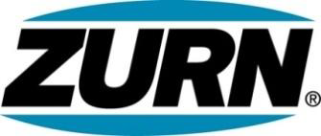

FOR IMMEDIATE RELEASE FOR MORE INFORMATION
DATE: June 3, 2014 Christine Verdecchia
Director of Communications
christine.verdecchia@zurn.com
814-875-1283

PHOTO: www.lopressroom.com/zurn/innovation-center

Zurn Fuels More Engineered Water Solutions
By Opening New Innovation Center in Cary, NC

ERIE, PA – Zurn Industries, LLC announces the opening of its new Innovation Center in Cary, NC – a move that reflects the company’s rapid growth in the commercial plumbing industry.

The 17,000-square-foot center will facilitate testing, quality control, product technology, and system innovations.

“As Zurn continues to drive market leadership through our escalation in innovation, we remain committed to delivering world class engineered water solutions,” says Scott McDowell, Global Vice President, Marketing and Business Development for Zurn. “This new facility sends a clear message to our employees, customers, and future customers that our drive to innovate isn’t slowing down but instead is gaining speed and resources.”

The Zurn Innovation Center will free up space in a nearby manufacturing plant in Sanford, NC, allowing that facility to meet a growing demand experienced by Zurn’s Commercial Brass and Fixtures Operations.

The Innovation Center, located at 3700 Regency Parkway in Cary, opened June 2, 2014.

About Zurn Industries
Zurn Industries, LLC is a recognized leader in commercial, municipal, healthcare and industrial markets. Zurn manufactures the largest breadth of engineered water solutions in the industry, including a wide spectrum of sustainable plumbing products. Zurn delivers total building solutions for new construction and retrofit applications that enhance any building’s environment. For more information, visit www.zurn.com.

