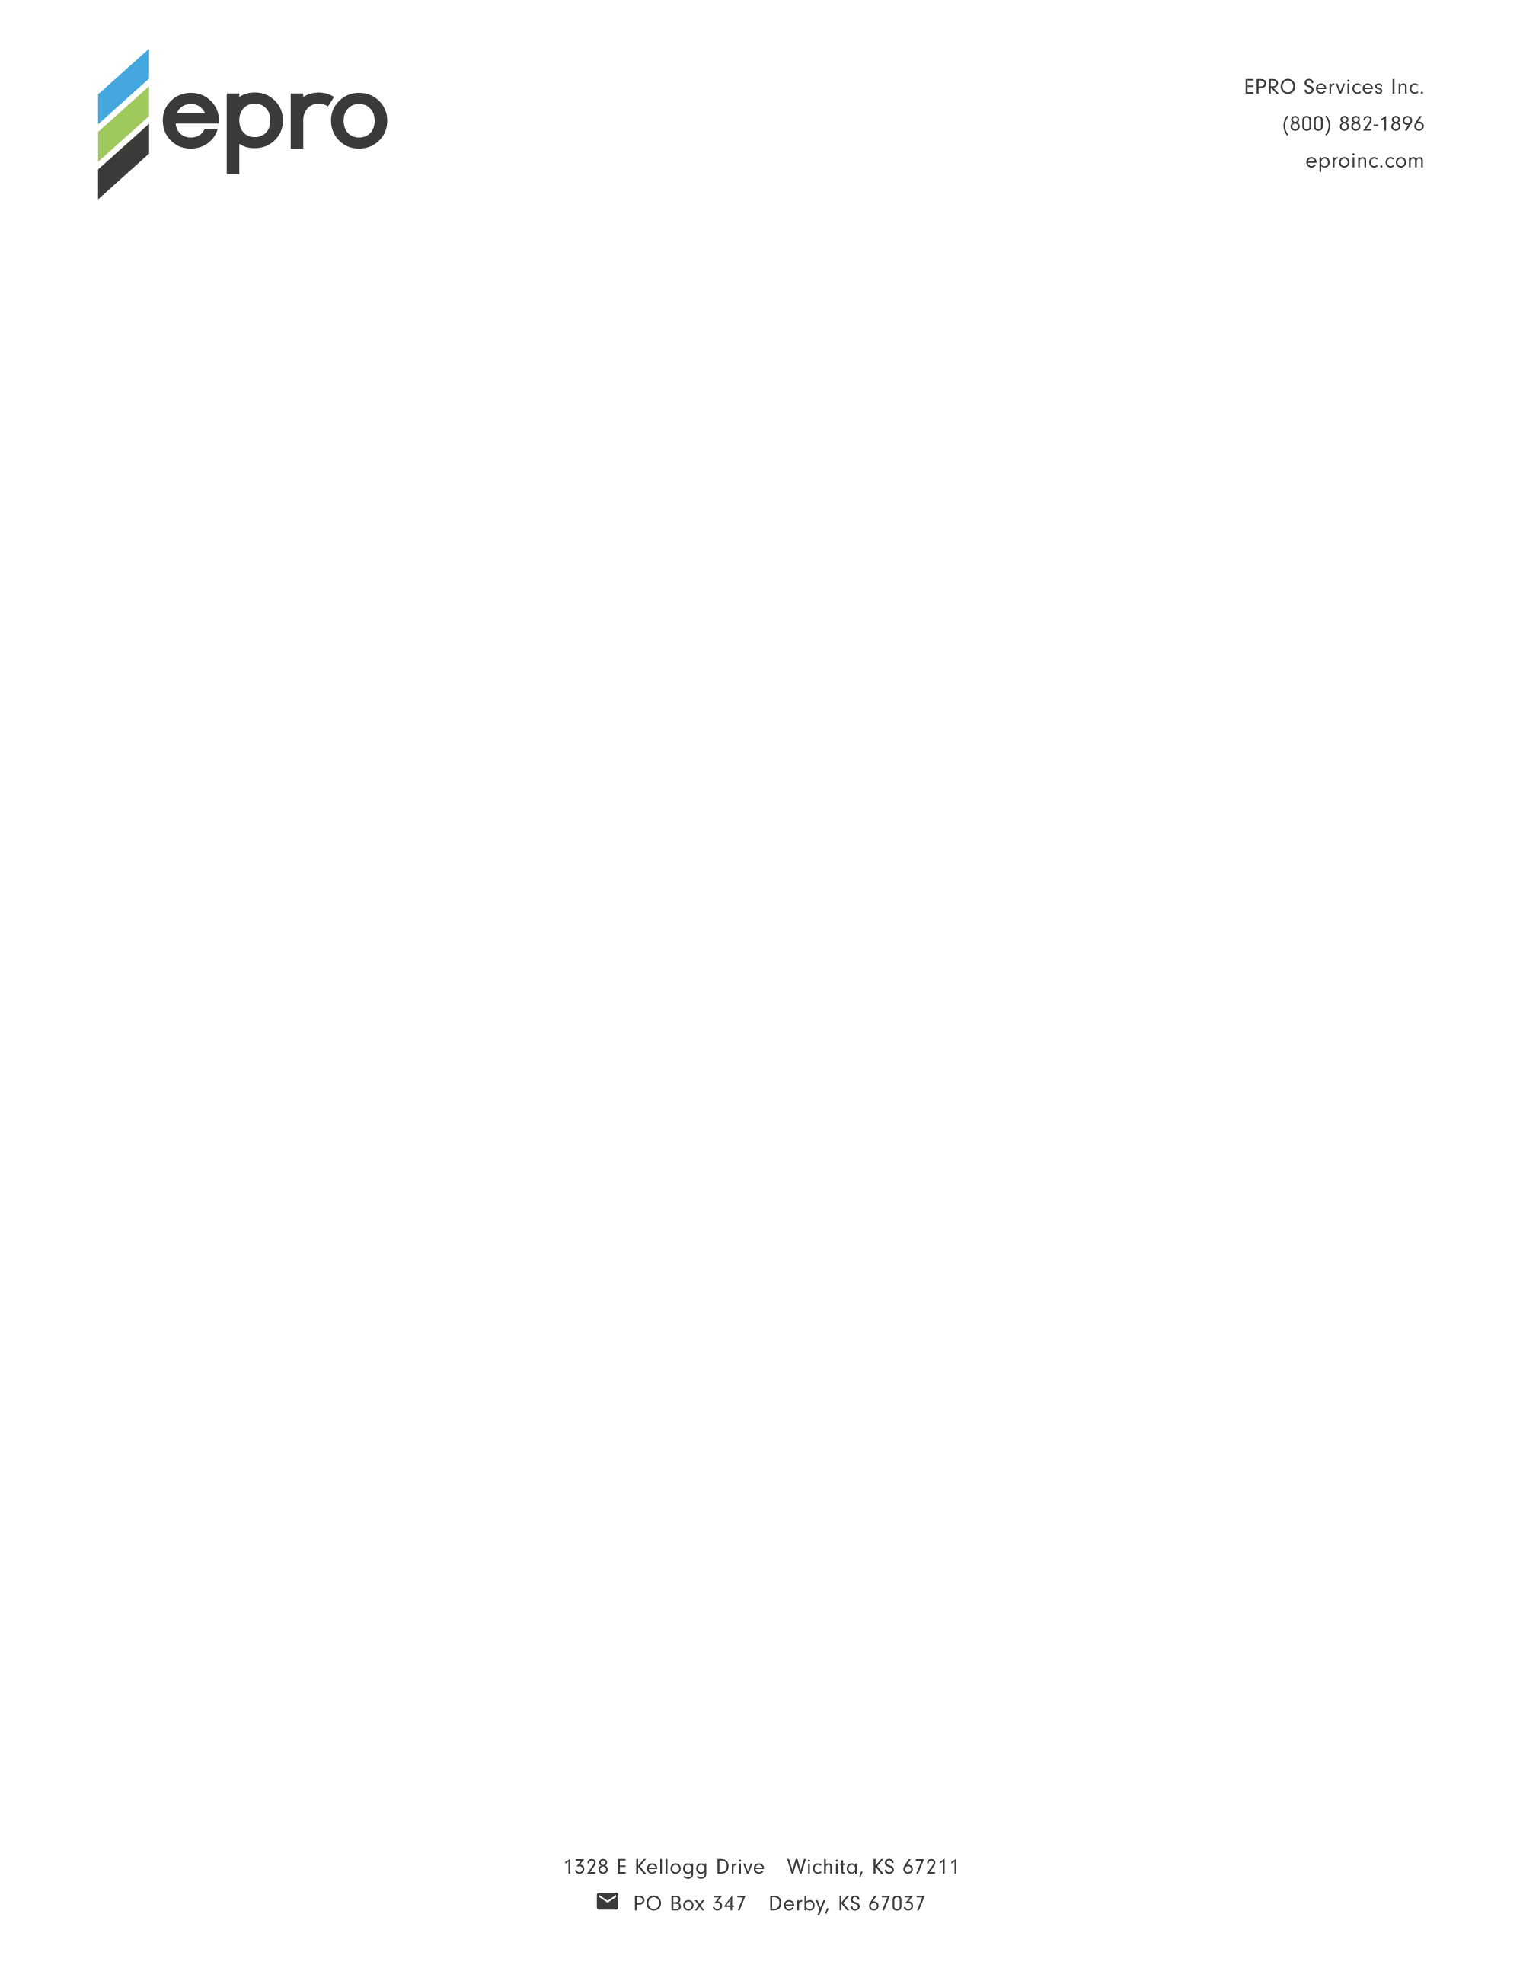

For Immediate Release
Contact: Nick Murosky, LarsonO'Brien
Email: nick@larsonobrien.com Phone: 412-831-1959 x123
Date: March 29, 2017
Photos: http://www.lopressroom.com/epro/e-series

EPRO Introduces E.Series Composite Waterproofing and Vapor Intrusion Systems
Existing Products and Systems Re-Branded to Make Specification Easier

WICHITA, KS… EPRO Services, Inc. (EPRO), an innovator of composite waterproofing, methane mitigation, and vapor intrusion systems, introduces E.Series – a tiered line of composite systems that leverage a variety of membrane materials to meet any performance need or project condition.

E.Series is comprised of three waterproofing systems for shoring, walls, decks, and underslabs:

- E.Protect+ is ideal when performance is paramount. It features a thermoplastic HDPE base course, a geocomposite bentonite protection sheet, and a minimum of 100 mils of polymer-modified asphalt.

- E.Protect provides a perfect compromise between performance and budget considerations. It features a geocomposite base course, a geocomposite bentonite protection sheet, and a minimum of 80 mils of polymer-modified asphalt.

- E.Proformance offers proven waterproofing for sites with lower risk. It features a geocomposite base course, protection sheet, and a minimum of 60 mils of polymer-modified asphalt.

Each system features built-in layers of redundancy. This redundancy is achieved by combining different types of waterproofing materials to leverage the positive attributes of each and eliminate a continuous seam. EPRO calls this Redundant Field-Installed Composite Design.

EPRO’s Redundant Field-Installed Composite Design philosophy represents the evolution of its products over the past 20 years, and is now demonstrated clearly by its E.Series line. It is now easier than ever for developers, designers, and contractors to determine the ideal waterproofing system for their project.

Formerly referred to as EPRO System III, individual products under the new E.Series line have also been re-branded. For a detailed list of new product names, along with references to the old names, visit: http://eproinc.com/e-series-product-and-system-names.

All E.Series systems and products are scaled to meet site conditions and performance goals, providing the project team with flexibility in process and in budget, and with waterproofing systems that meet the demanding requirements of modern day construction.

In addition, EPRO stands behind its process with the E.Assurance warranty program, which includes No Dollar Limit Labor and a Material Warranty. E.Assurance consists of four main steps: Plan Review, Installation Coordination, Inspection Protocol, and Warranty Service. For more information, visit: http://eproinc.com/e-assurance.

Visit EPRO online: www.eproinc.com

About EPRO Services, Inc.: EPRO makes building products to keep structures dry and safe. Founded on the belief that redundant systems provide the best protection, EPRO provides composite waterproofing and vapor intrusion systems for all types of performance needs and project conditions. For more information, call 800-882-1896 or visit www.eproinc.com.

# # #

